Animal Care & Control
We Love Volunteers!
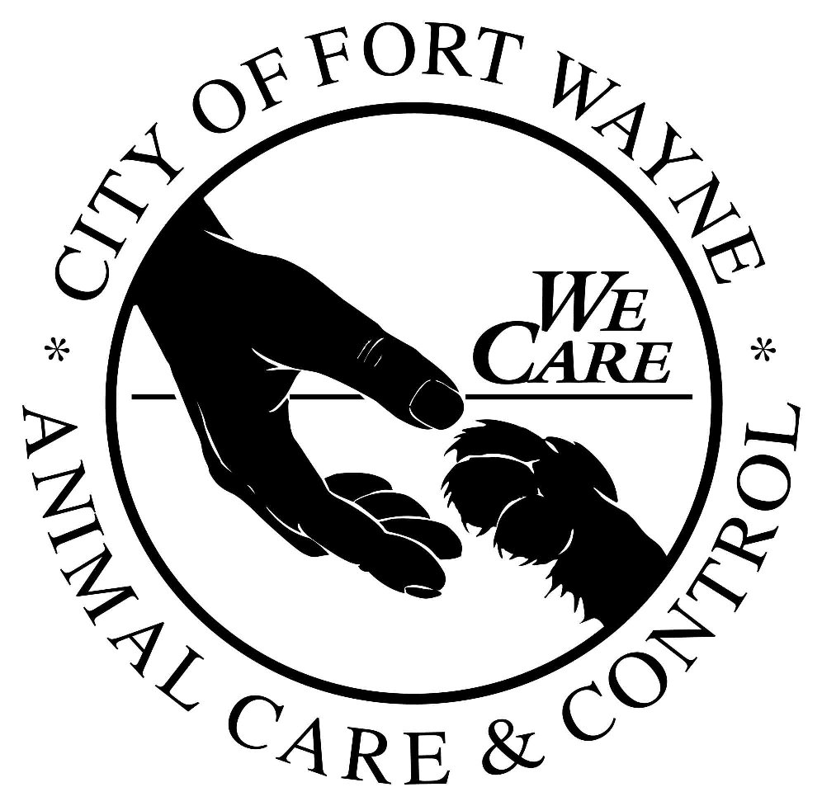
VOLUNTEER QUESTIONNAIRE
Thank you for choosing to be a volunteer for the animals!
Our Mission:
Guided by the humane ethic and livability interests within our neighborhoods, the mission of Fort Wayne Animal Care & Control is to ensure public health and safety as well as prevent pet overpopulation, animal neglect, and animal cruelty through education, rescue, and law enforcement.
In order to submit this form by e-mail, please fill it out, save it as a file on your computer and attach it in an e-mail to our Volunteer Coordinator:
Emilee.Smith@cityoffortwayne.org

Name: ____________________________________________

Address: ___________________________________________

City: ______________________________State: ______ Zip:_______________

Home Phone: __________________________Cell Phone: ____________________________

E-mail: ________________________________

Employer: _________________________________

Are you over 18 years old: YES NO

Please list an emergency contact and their phone number:

Please tell us about your pets/experience with animals:

Why do you want to volunteer at Animal Care & Control? Besides a love of animals, what would you like to get out of your volunteering experience?

Please know that we take volunteering very seriously. Volunteers must commit to 40 hours over the course of a year. With that being said we have volunteers in specific positions on scheduled days/times. Please list your availability that you are able to volunteer (days and times):

What types of volunteer work are you interested in doing? (Check all that apply)
Helping Clean Dog Kennels/Cat Room Clerical
Walking Dogs Community Outreach
Laundry/Dishes Special Events
Greeting our Guests Adoption Counseling
Socializing Cats Small Animals (Cleaning/Socializing)

As a government agency, there are some questions we are required to ask.
Have you ever been convicted of or pled guilty to a felony? YES NO

Are you willing to submit to a background check including drug screen and police check?
YES NO

PLEASE NOTE: If you will be volunteering on-site and are required to drive your own vehicle, proof of a driver’s license and auto insurance with a minimum of $100,000 liability insurance is required.

Please list two references that are not family members (name and phone):

A volunteer is someone who chooses to act in recognition of a need, with an attitude of social responsibility and without concern for monetary profit. Volunteers enhance the work of Animal Care & Control. A volunteer is not an employee and is not compensated for his or her services.

By signing below, I certify that the statements made in this application are true and correct and have been given voluntarily. I understand that Animal Care & Control may require me to have a drug screen and that they may do a police background check and I am willing to submit to both. I understand that this information may be disclosed to any party with legal and proper interest, and release Animal Care & Control from any liability whatsoever for supplying such information.

Your Signature and Date: ______________________________________

CITY OF FORT WAYNE
THOMAS C. HENRY, MAYOR
Animal Care & Control

Fort Wayne Animal Care & Control
CRIMINAL CHECK AUTHORIZATION

I, _____________________________(enter your name), hereby authorize Animal Care & Control to obtain information pertaining to any charges and/or convictions I may have had for federal and state criminal law violations. This information will be gathered from any law enforcement agency of this state or any state or federal government, to the extent permitted by state and federal law.

Your Signature and Date: _______________________________________________

Your name as it appears on Legal Documents:

Full first name: ____________________________________________________

Full Middle Name: ____________________________________________________

Maiden last name: ____________________________________________________

Married last name: ____________________________________________________

Date of birth (including year): _______________________

Social Security Number or State Identification Number: ______________________

Drivers License Number: _____________________ Expiration Date: __________

State of Issuance: __________

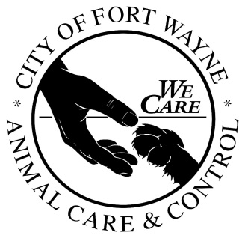

Fort Wayne Animal Care & Control
COMMITMENT TO CAUSE

Our Mission:
Guided by the humane ethic and livability interests within our neighborhoods, the mission of Fort Wayne Animal Care & Control is to ensure public health and safety as well as prevent pet overpopulation, animal neglect, and animal cruelty through education, rescue, and law enforcement.

This Department’s policies concerning spay/neuter promotion, adoptions, and euthanasia have been developed as a proactive approach to responsible pet ownership and pet overpopulation. The success of this approach is possible with the support of every volunteer. Although my personal opinions may differ, I recognize that while I am a volunteer representing Animal Care & Control, I represent this approach to citizens of Fort Wayne.

If a situation should arise that a citizen wishes to engage in a conversation about a policy issue such as euthanasia and I am uncomfortable discussing or defending, I will seek a staff member’s assistance.

If at any point in time I can no longer in good faith support these policies with my time and talents, I will respectfully resign.

Your Signature and Date: ______________________________________________

