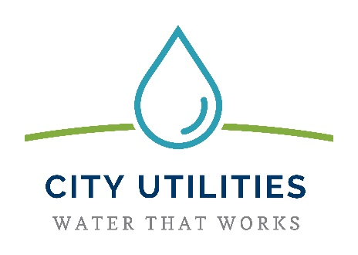
CITY UTILITIES
200 E Berry Street, Suite 250
Fort Wayne, IN 46802
August, 2019

Dear Crestwood Colony Resident or Property Owner:

I am pleased to inform you that City Utilities has hired a contractor to replace water mains on several streets in your area. Water mains on these streets have experienced a large number of main breaks over the past few years. This replacement project will reduce the number of breaks expected in the future and is part of City Utilities’ master plan for improving portions of the water main system that serve the northwest part of Fort Wayne.

The replacement involves the installation of approximately 21,325 feet of water main. Please reference the map on the back side of this letter for where this is replacement is occurring. Once installed, new water service lines will be installed and re-connected to your existing water service line.

Rothenberger Company, Inc. has been awarded the contract for this project. Work is expected to take place through October 26th, 2020.

I know that utility construction projects can be disruptive for neighborhoods while they are going on. It is the goal of our staff to keep you well-informed about what is expected to happen during the project. I want you to know who to contact to answer your questions and resolve any construction issues. Please join City Utilities for an opportunity to “Meet the Contractor” and learn more about this important project and how it will impact you.
Wednesday, October 2nd, 2019 at 6:00 PM
Northwood Middle School - Cafeteria
1201 E. Washington Center Road
Fort Wayne, Indiana

The school is accessible for persons with disabilities. If you need further accommodation such as a language or sign language interpreter, please contact the Construction Manager - Zack Schaefer, whose contact information is shown below, at least 48 hours prior to the meeting so that we can make the appropriate arrangements.

Every effort will be made to maintain the best possible traffic flow during the construction period. Please let me know if you have suggestions about how the City can improve projects like this one or any other City services by calling 311 or 427-8311. For specific questions about this project during the construction period, please contact City Utilities’ Construction Manager for the project: Zack Schaefer at 260-427-2704 or by email at zack.schaefer@cityoffortwayne.org.

Sincerely,

Zack Schaefer⎮Construction Contract Manager
City of Fort Wayne Utilities
260-427-2704 (Office)

