CITY OF FORT WAYNE MASTER UPDATED: 8/17/2017
SECTION 27 05 53
IDENTIFICATION FOR COMMUNICATION SYSTEMS
- GENERAL
  - SUMMARY
    - Furnish all labor, materials, equipment and incidentals required to label cabinets and appurtenances as shown on the Drawings, specified and required.
      - The system includes cabinet / rack labeling, panel labeling, port labeling, cable labeling, and related appurtenances.
    - Related Sections
NTS: List below only sections covering products, construction and equipment that a user might expect to find in this section, but are specified elsewhere. Do not list administrative and procedural division 01 sections.
      - Section 26 05 53, Identification For Electrical Systems
      - Section 27 13 24, Fiber Optic Cable and Appurtenances
      - Section 40 67 03, Process Control Equipment Panel Construction
  - REFERENCES
    - Reference Standards: Comply with the latest edition of the applicable provisions and recommendations of the following, except as otherwise shown or specified:
      - ANSI/EIA/TIA-568 Cabling Components Standard
      - ANSI/EIA/TIA-598 Optical Fiber Cable Color Coding
  - SUBMITTALS
    - Submit the following:
      - Shop Drawings: Submit the following:
        - Complete description and listing of proposed electrical identification and electrical identification devices for associated equipment or systems.
        - Conduit and wire identification numbering system and equipment signage.
      - Product Data:
        - Manufacturer’s literature, cut sheets, specifications, dimensions and technical data for all products proposed under this Section.
      - Samples: For each type of label and sign to illustrate size, colors, lettering style, mounting provisions, and graphic features of identification products.
      - Identification Schedule: An index of nomenclature of electrical equipment and system components used in identification signs and labels.
- PRODUCTS
  - IDENTIFICATION MATERIALS
    - The size, color, and contrast of all labels shall be selected to ensure that the identifiers are easily readable. Text shall be black letters on a white field
    - Communication Cables and Fiber Label Type
      - Self-Adhesive Vinyl Labels: Preprinted, flexible label laminated with a clear, weather- and chemical-resistant coating and matching wraparound adhesive tape for securing ends of legend label.
    - Rack Label Type
      - Adhesive Film Label with Clear Protective Overlay: Machine printed, in black, by thermal transfer or equivalent process. Minimum letter height shall be 3/8 inch (10 mm). Overlay shall provide a weatherproof and UV-resistant seal for label.
    - Raceway Label Type
      - Comply with ANSI A13.1 for minimum size of letters for legend and for minimum length of color field for each raceway and cable size.
- execution
  - PROCESS CONTROL NETWORK AND BUSINESS INFORMATION NETWORK
    - Network / Cabinet Labeling Example
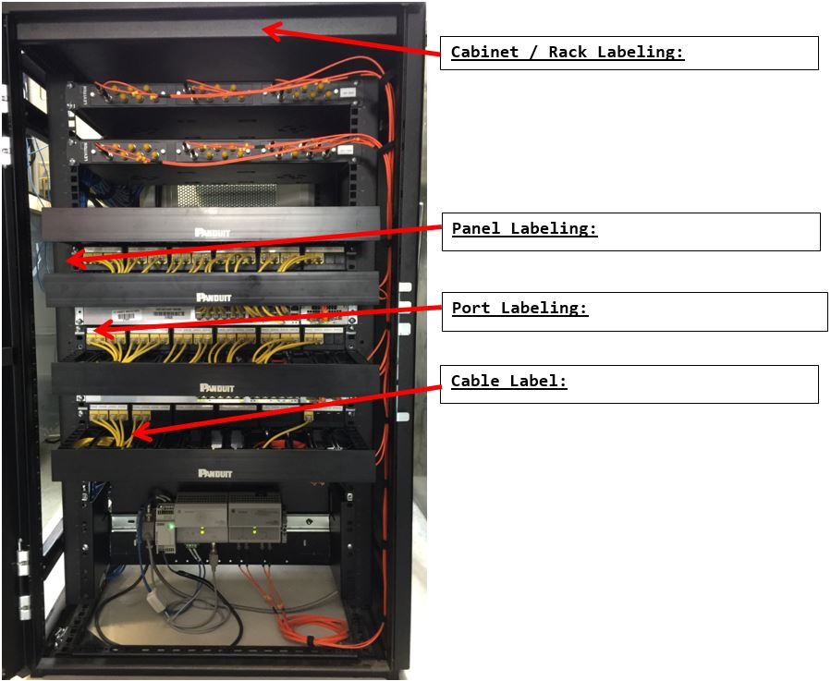
    - Cabinet / Rack Labeling
      - Label shall be placed on the network enclosure on the patch panel side top center. Typical industrial application is a single rack in a location (building, area of a facility). Where multiple racks exist, racks shall be incrementally labeled left to right from the front of the enclosures.
      - Cabinet / Rack Label Format
        - ‘LLLLRN’
        - LLLL = Location
        - R = Rack delimiter
        - N = Rack number in the location
      - Example: 0725R1 {Rack 1 in Location 0725}
    - Panel Labeling
      - Label shall be placed within the network rack on the left side rack mount identifying the horizontal position of a device (Patch panels, active devices, etc.). Empty rack units and wire management devices do not require a label. Labeling should follow manufacturers markings. Panel labeling may include the Cabinet / Rack Labeling.
      - Panel Label Format
        - ‘-UU’
        - - = Unit delimiter
        - UU = Rack Unit Number
      - Examples:
        - 26 {Rack Unit 26}
        - 0725R1-26
    - Port Labeling
      - Label shall be placed identifying the individual ports of a device. All ports to be labeled with the Near End or Far End labels depending on the location. Near End is the ‘FROM’ and is the closest to the Main Distribution Frame (MDF). The Far End is the ‘TO’, which may be another Distribution Frame or the end device.
      - Port Label Format
        - ‘:EE’
        - : = Port delimiter
        - EE = Port Number at the location {Near End (From) / Far End (To)}
      - Examples:
        - 0725R1-26:06 {Port 06 on device in panel position 26 of rack 1 in location 0725}
        - 0725LCP-01:02 {Port 02 on local control panel 01 in location 0725}
        - 0725VFD-02:01* {Port 01 on VFD 02 in location 0725}
        - *For consistency, devices with a single port shall include port Location.
    - Cable Labeling
      - Cables labels are identified with information that defines the connection between the near end panel connection (FROM) and the far end panel connection (TO). The near end connection is the connection that is closest to the Main Distribution Area (MDA) in the network topology. A near end connection identifier would consist of the cabinet/rack location, panel location, and port location. The far end connection identifier would consist of the cabinet/rack location, panel location, and port location. Cable labels can show the Near End and Far End by one of the following: 2 lines, 2 labels, or a single line separated by ‘/’ .
      - Cable Label Format
        - ‘LLLLRN-UU:EE’
          - LLLL = Location
          - R = Rack delimiter
          - N = Rack number in the location
          - - = Unit delimiter
          - UU = Rack Unit Number
          - : = Port delimiter
          - EE = Port Number at the location {Near End (From) / Far End (To)}
NTS: Labeling options are provided to the Contractor below. Edit as needed.
      - Cable Label Layout
        - Line 1 - Near end ‘FROM’ {closest to the Main Distribution / SCADA servers}
Line 2 – Far End ‘TO’
        - Or Near End / Far End
        - Or Label 1 – Near End and Label 2 – Far End
      - Examples:
        - 0725R1-26:06 {Port 06 on device for position 26 located within rack 1 in location 0725}
        - 0725VFD-02:01 {VFD02 in building 0725}
        - 0725R1-26:06/0725VFD-02:01
        - Label 1 - 0725LCP-01:02 {Port 2 for Local Control Panel 01 in location 0725}
Label 2 – 0725PLC-01:01 (Port 1 for PLC 01 in location 0725}
  - FIELD CONTROL NETWORK
NTS: Designer shall label wire diagrams consistent with the format and information listed below.
    - Wire and Cable Identification System:
      - Wire and cable labels shall be imprinted with an identifying designator.
        - Instrumentation, Network Cables and Control Wiring
          - Wire or cable designator shall consist of the following designator and format: Four-digit PLC number one digit cabinet number followed by a hyphen followed by a three digit page number and three digit line number (in increments of ten).
          - Format: PPPPC-NNNLLL
            - Example: 10001-115010
            - PLC Number:1000
            - Cabinet Number:1
            - Page Number:115
            - Line Number: 010
  - FIBER OPTIC CABLE IDENTIFICATION
    - Unit Position Color Code for Loose Tube (TIA-598)
      - Position 1: Blue
      - Position 2: Orange
      - Position 3: Green
      - Position 4: Brown
      - Position 5: Gray (Slate)
      - Position 6: White
      - Position 7: Red
      - Position 8: Black
      - Position 9: Yellow
      - Position 10: Violet
      - Position 11: Rose (Pink)
      - Position 12: Aqua
    - Fiber connector colors
      - Fiber Type: 62.5/125
        - Connector Body: Beige
        - SFP / SFP+: Beige
      - Fiber Type: 50/125
        - Connector Body: Black
        - SFP / SFP+: Black
      - Fiber Type: 50/125 (laser optimized)
        - Connector Body: Aqua
        - SFP / SFP+: Aqua
      - Fiber Type: Single Mode
        - Connector Body: Blue
        - SFP / SFP+: Blue
  - FIBER ADAPTER PANEL IDENTIFICATION
    - Fiber adapter panel shall be labeled from left to right.
    - Path ports shall be labeled top to bottom.
  - DIRECTORY
NTS: Designer shall provide an instrumentation and device identification diagram similar to a directory for an electrical power panel. Instrumentation and device identification diagram shall include PLC, VFD, HMI, etc followed by the unique device identifier.
Devices identifiers to be approved by Owner.
    - Directory: Typed or computer-printed card, with transparent protective cover in frame on back of door giving circuit numbers and area or equipment served.
      - The directory shall include the following columns:
        - Near End (From)
        - Far End (To)
        - Device Description
    - Legends shall be easily accessible and visible near the port locations(s) or near the end device port location.
    - Example End Device:
Far End (To) | Near End (From) | Device
0725VFD-02 | 0725R1-26:06 | Effluent Aeration Blower 2
    - Example Network Rack:
Near End (From) | Far End (To) | Device
0725R1-26:01 | 0725LCP-01:01 | Effluent Aeration Local Control Panel 01 : PLC (Slot 2)
0725R1-26:02 | 0725LCP-01:02 | Effluent Aeration Local Control Panel 01 : HMI
0725R1-26:03 | 0725LCP-01:03 | Effluent Aeration Local Control Panel 01 : PLC (Slot 3) Modbus TCP/IP
0725R1-26:04 | 0725LCP-01:04 | Spare
0725R1-26:05 | 0725VFD-01 | Effluent Aeration Blower 1
0725R1-26:06 | 0725VFD-02 | Effluent Aeration Blower 2
.
.
.
0725R1-26:24 |  | Spare
  - INSTALLATION
    - Devices include equipment with connections (patch panel, switch, etc). Devices could be active or inactive.
    - Slashed zero font to be used on all markings
    - The number of digits used for all numbers should be consistent with the total number of positions/ports. For example, if device has 24 ports, labels shall be labeled 01 through 24.
    - Cabinet / Rack shall include additional label for each power source. Including power panel, circuit number, and UPS identification. Powered devices within the rack shall be clearly marked for the power source. When a server rack includes multiple servers with independent power sources clearly label which power source provides power for each device.
NTS: Designer shall provide a list of items that require labels. Add or delete labels to meet Project specific requirements.
    - Additional items that require labels:
      - Grounding labels
      - Busbar label
      - Power Cables
      - Safety, Fire, and Security
NTS: Designer shall coordinate with 26 05 53 Identification for Electrical Systems.
    - Conduit Labels:
      - Provide conduits with conduit labels unless otherwise shown or indicated.
      - Do not label flexible conduit.
      - All conduit of any length shall have a minimum of one label.
      - Provide conduit labels at the following locations:
        - Where each conduit enters and exits walls, ceilings, floors, or slabs.
        - Where conduit enters or exits boxes, cabinets, consoles, panels, or enclosures, except pull boxes and conduit bodies used for pull boxes.
        - At maximum intervals of 50 feet along length of conduit.
      - Orient conduit labels to be readable. Text shall be left to right on horizontal conduits and down to up on vertical conduits.
    - Wire and Cable Identification:
      - Text shall be left to right on horizontal conduits and down to up on vertical conduits.
      - Do not provide labels for the following:
        - Bare (uninsulated) conductors, unless otherwise shown or indicated as labeled.
      - Provide wire and cable labels for the following:
        - New, rerouted, or revised wire or cable.
        - Insulated conductors.
        - Wire and cable terminations:
          - Wire labels shall be applied outside of the wireway between the wireway and the terminal.
          - Apply cable labels between 1/2-inch and one inch of cable breakout into individual conductors.
            - Label individual conductors in a cable after breakout as specified for wires.
        - Wire or cable exiting cabinets, consoles, panels, terminal boxes, and enclosures.
          - Label wires or cables within two inches of entrance to conduit.
        - Wire or cable in junction boxes and pull boxes
          - Label wires or cables within two inches of entrance to conduit.
        - Wire and cable installed in cable tray.
          - Wire and cable shall have labels at maximum intervals of 20 feet.
        - Wire and cable installed without termination in electrical manholes.
          - Wire and cable shall have wrap-around labels applied within one foot of exiting manhole.
      - Modified Cabinets, Consoles, Panels, and Enclosures:
NTS: Designer shall consult Owner on labeling of cabinets, consoles, panels, and enclosures. Where existing equipment naming differs from format listed above Designer shall coordinate with Owner.
        - New or rerouted wire or cable in existing cabinets, consoles, panels, and enclosures shall be labeled using the same format and designation as shown above where possible. Where existing equipment naming differs from format listed above coordinate with Owner.

+ + END OF SECTION + +

